**Assignment 4 Conceptual Database Design by Joshua Troup**

**1.**

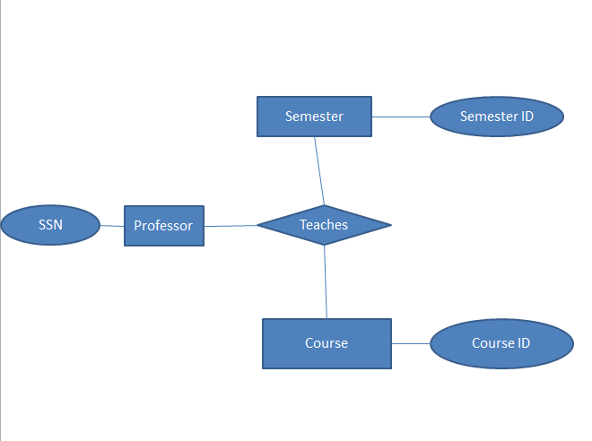

The entity Semester has to be identified by a Semester ID with the relation Teaches will be identified by SSN, Semester ID, and Course ID.

**Participation Constraints:**

**Key Constraints:** SSN, Semester ID, Course ID

2. 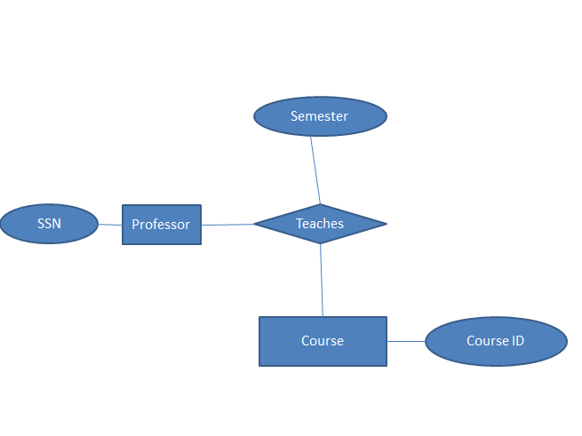

Semester is no longer the entity but is now an attribute since most recent needs to be recorded. SSN and Course ID identify the relation Teaches.

**Participation Constraints:**

**Key Constraints:** SSN, Course ID

3.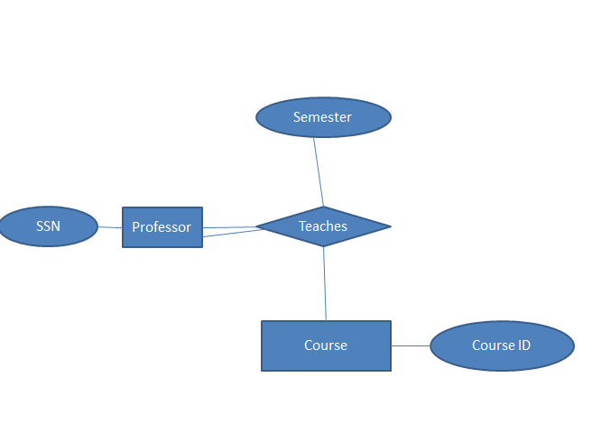

A constraint on Professor (Double line in diagram) in relation to Teaches. Each professor must teach at least one course.

**Participation Constraints:** Professor -> Teaches, Teaches -> Course

**Key Constraints:** SSN, Course ID

4. 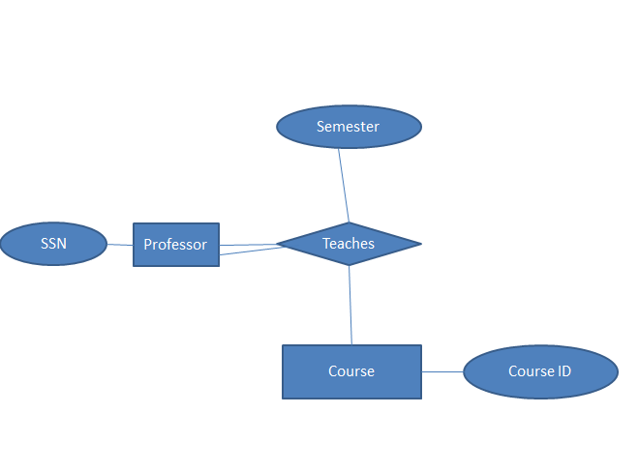

Total participation constraint between Professor and Teaches as a professor teaches exactly one course. The SSN identifies the course taught.

**Participation Constraints:** Professor -> Teaches (Total Participation), Teaches -> Course

**Key Constraints:** SSN

5. 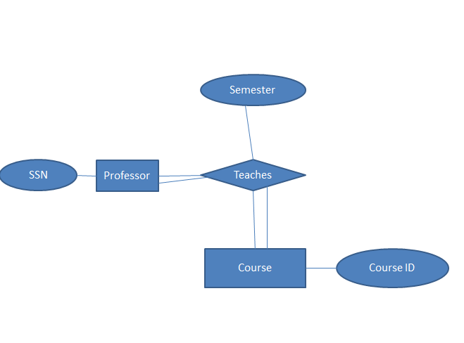

Total participation of Course in relation to Teaches (Double Lines—every course must be taught by some professor). SSN still continues to identify the course taught.

**Participation Constraints:** Professor -> Teaches (Total Participation), Teaches -> Course

**Key Constraints:** SSN

6. 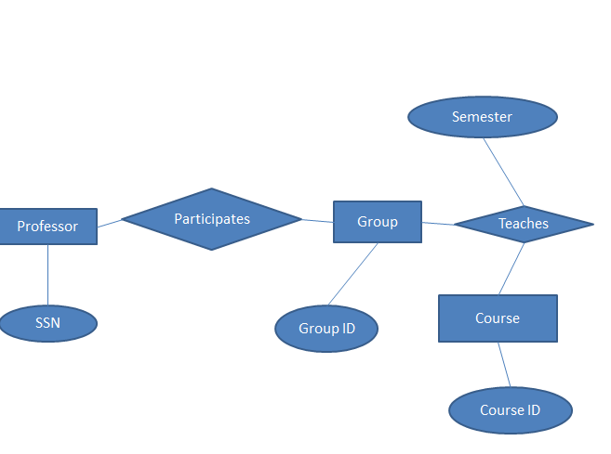

Entity Group represents the group of professors. The relation Participates between Professor and Group show that a Professor is a member of the group of professors. Relation Teaches applies to Group and Course which shows a Group teaches a certain course.

**Participation Constraints:** Professor-> Participates

**Key Constraints:** SSN, Group ID, Course ID